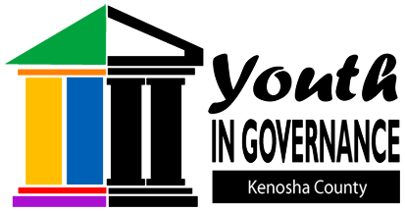
Kenosha County Youth in Governance
19600 – 75th Street, P.O. Box 550
Bristol, WI 53104
262-857-1945
(FAX) 262-857-1998
2018-2019 Annual Report

Background
Youth leadership development is critical in building civic capacity and long-term community sustainability in Kenosha County. Programs that teach useful skills and build the self-confidence of young people ensure capable, effective leaders for the next generation. Data from a 2006 Kenosha County Search Institute survey documented that only 23% of youth perceive that their community values youth and only 27% believe that youth are given useful roles in the community. These results were among the lowest of all the assets measured and were lower than similar assets measured at a national level. In direct response to these survey results, the Kenosha County Board of Supervisors created the Kenosha County Youth In Governance (YIG) program in 2007. The purpose of the Youth In Governance program is to create a model of youth empowerment within Kenosha County, through direct participation in local government. The overall goal is to bring the youth voice to community issues and concerns while fostering the development of confident, independent, and motivated youth leaders.

Nomination and Selection Process
Nomination forms for the 2018 – 2019 Youth In Governance program were distributed to all thirteen (13) public and private high schools in Kenosha County. Of these thirteen (13), eight (8) high schools along with three (3) other youth-serving organizations nominated a total of 85 youth to participate in the program. Of the 85 nominees that were mailed an application and reference form, 18 completed applications, and 18 were granted interviews. Of the 18 interviewed, the names of 14 individuals were forwarded to Kenosha County Board Chairman Esposito for official appointment to a Kenosha County Board Committee. Please see TABLE A for specific nomination and selection statistics.
Name of High School | Number of Nominations | Number of Applications | Invited to Interview | Selected as YIG Participant
Bradford | 0 | 0 | 0 | 0
Catholic Central | 0 | 0 | 0 | 0
Christian Life | 6 | 3 | 3 | 2
Harborside Academy | 3 | 0 | 0 | 0
Indian Trail Academy | 6 | 0 | 0 | 0
Kenosha Military Academy | 0 | 0 | 0 | 0
Lakeview Technology | 13 | 3 | 3 | 3
Reuther | 0 | 0 | 0 | 0
St. Joseph Catholic | 2 | 0 | 0 | 0
Shoreland Lutheran | 1 | 1 | 1 | 1
Tremper | 21 | 4 | 4 | 4
Westosha Central | 30 | 6 | 6 | 4
Wilmot | 0 | 1 | 1 | 0
Nominated by Others | 3 | 0 | 0 | 0
TOTAL | 85 | 18 | 18 | 14
TABLE A

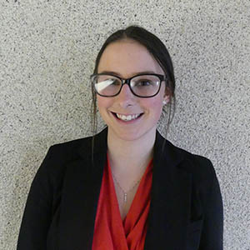  Katherine Bogdala  Legislative | 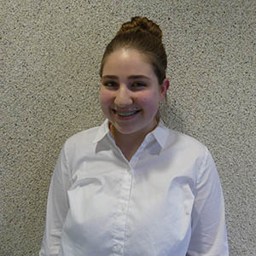  Grace Bourdeau  Joint Services | 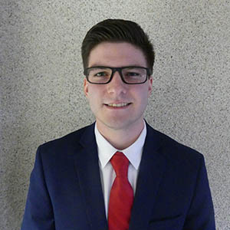  Chance Ciskowski  Human Services | 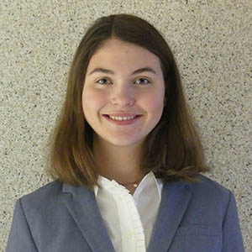  Victoria Desimoni  PDEEC
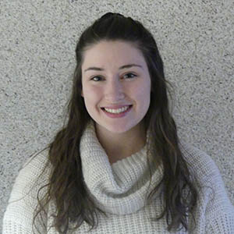  Victoria Esposito  PDEEC | 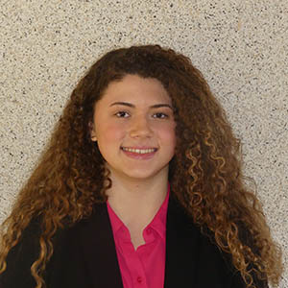  Maria Grenyo  Judiciary & Law | 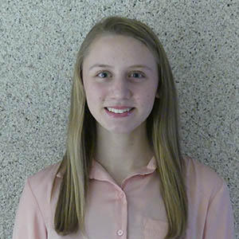  Anika Katt  Finance/Administration | 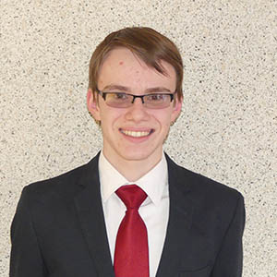  Jacob Maki  Joint Services
Chas Miles  Public Works | Daniel Mleczko  Finance/Administration | 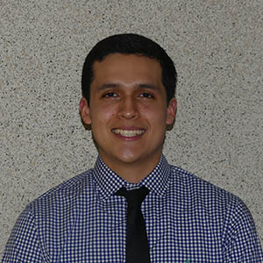  Javier Retana  Public Works | 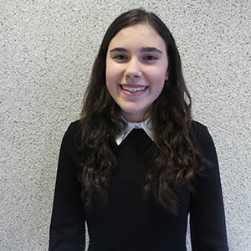  Isabella Ricker  Human Services
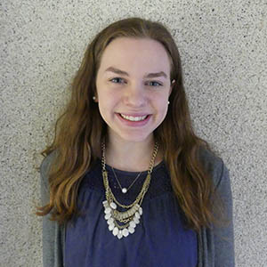  Mackenzie VanDixhorn  Judiciary & Law | Kenosha County  Youth in Governance Members  2018-2019 |  | 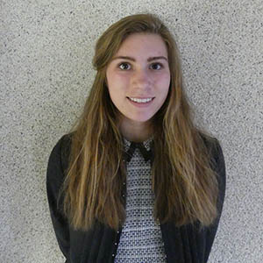  Elizabeth Vankammen  Legislative
Evaluation and Impact
Near the end of their term, all Youth In Governance members were given the opportunity to complete a retrospective evaluation. Quantitative information about civic engagement and leadership skill development are highlighted in TABLE B and TABLE C. Qualitative information is also shared through direct quotes from youth in response to three specific questions.

N = 9 of 14  CIVIC ENGAGEMENT | # of Youth Reporting No Change | # of Youth Reporting 1 Unit of Change | # of Youth Reporting 2 or > Units of Change
I am knowledgeable about Kenosha County Government | 1 | 3 | 4
I am aware of local issues that affect Kenosha County | 1 | 6 | 1
My opinion can make a difference in the community | 3 | 3 | 2
I have a useful role in the community | 1 | 4 | 3
I feel a strong connection to Kenosha County | 4 | 3 | 1
I am interested in politics | 5 | 1 | 2
TABLE B
N = 8 of 14  LEADERSHIP SKILLS | # of Youth Reporting No Change | # of Youth Reporting 1 Unit of Change | # of Youth Reporting 2 or > Units of Change
I can participate in group discussions with adults | 2 | 5 | 1
I can share new ideas with others | 5 | 2 | 1
I can speak confidently before a group of adults | 2 | 5 | 1
I can see issues from multiple perspectives | 6 | 2 | 0
I can talk knowledgeably with others about local issues | 1 | 4 | 3
I can be a resource to people in Kenosha County | 0 | 4 | 4
TABLE C

QUESTION #1
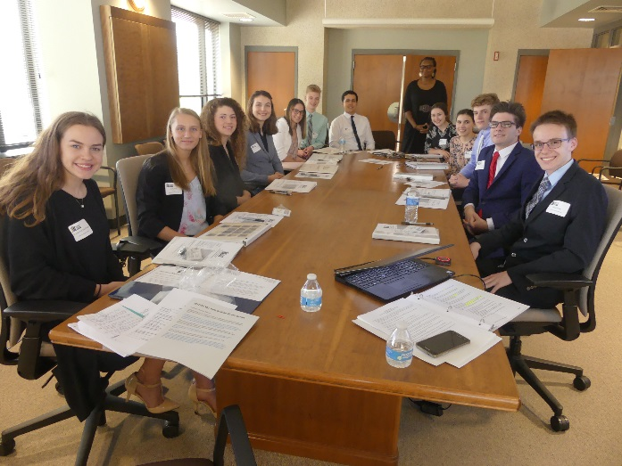
One goal of the Kenosha County Youth In Governance program is to create an environment that is conducive to the positive development of youth voice and youth engagement. Do you feel the YIG program accomplished this goal? Why?

“Yes, I felt like the supervisors were really helpful in the meetings and were always interested in my point of view.”

“Yes, I do. I have become much more engaged in my community since joining YIG and had a place to voice my opinions.”

“Yes, I feel that YIG provided youth members with an environment that was comfortable and open for discussion. I feel like my opinions were valued by the members of the committee that I served on.

“I absolutely feel the YIG Program accomplished this goal. Prior to YIG I felt the most I had to contribute to my community was some volunteering, but now advocacy has also become a part of my community involvement.”

QUESTION #2
Another goal of the Kenosha County Youth In Governance program is that the program would provide youth with skills, knowledge, and experiences to prepare them for future leadership opportunities. Do you feel the YIG program accomplished this goal? Why?

“This program definitely aided my leadership skills along with my role in my schools Student Government president, with stronger discussion and people skills altogether.”

“I feel like it has helped the students more be able to talk to adults and start to move into that world.”

“I think the YIG Program accomplished this goal, because this program gave me the opportunity to become a leader in my community and taught me those valuable skills.”

QUESTION #3
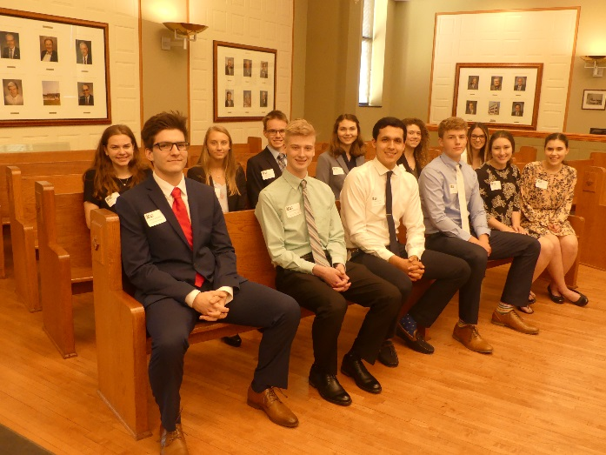
What has been the most important thing you have gained from participation in the Kenosha County Youth In Governance program?

“I was able to better understand the involvement of government through a county perspective.”

“I feel the most important thing I gained was my understanding of others view points and that most people are trying to make the best decisions for our county.”

“I would say the fact that I feel a lot less timid in a room full of professional adults.

“YIG has provided me with a real life insight into what a career in the fields I am considering actually entails. This was incredibly valuable to me as I made decisions about my future.

“My confidence speaking with adults has definitely improved throughout my term. I’m happy to say that I no longer find myself hesitant to voice my opinion.”

“I think I learned how to see both sides of issues better as well as how to speak to adults more effectively.”

Kenosha County Youth In Governance is a program of Kenosha County UW-Extension in partnership with the Kenosha County Board of Supervisors. University of Wisconsin, U.S. Department of Agriculture and Wisconsin counties cooperating. An EEO/AA employer, University of Wisconsin Extension provides equal opportunities in employment and programming, including Title IX and American with Disabilities (ADA) requirements.

