

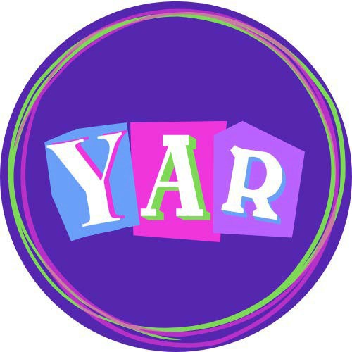
Kenosha County Youth As Resources

Board of Directors 2026-2027
As a member of Kenosha County Youth As Resources, I will support my community by giving back.
I will transform myself by building knowledge and skills. I will commit myself to the idea that youth can be leaders.
I am a resource.

Kenosha County Youth As Resources Board Manual
Welcome 1
History 1
Website 1
Overview 2
Board Officers 2-3
Board Meeting 4
Sample Agenda 5-6
President’s Remarks for Granting Meetings 7
Sample Questions to ask Service Project Presenters 8
Board of Directors Roster 9
Board of Directors Photos 10
Committees 11
Schedule 12
Bylaws 13-15
Conflict of Interest Policy 16
Endowment Fund 17
Leonard and Patricia Johnson Award 18
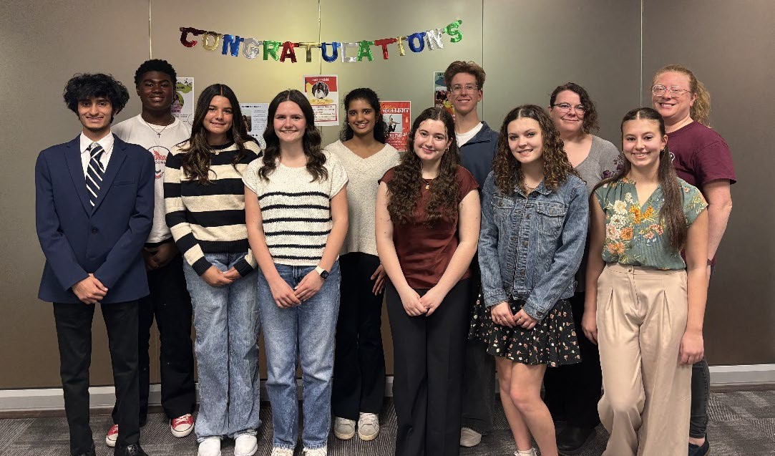

Welcome
Welcome to Youth As Resources. You have become a part of a growing movement that is recognizing young people for their tremendous potential to positively influence the world around them.

Youth As Resources (YAR) is a grant giving organization that helps youth groups in Kenosha County to plan and implement meaningful community service and service-learning projects. By involving youth in their communities, YAR not only empowers young people to be active and engaged citizens, but it also strengthens the communities of Kenosha County.

By joining Youth As Resources, you are dedicating yourself to the goals and ideals of Youth As Resources. This manual is intended to help you understand how YAR works and to provide valuable board member resources throughout the year. Congratulations and thank you for making this commitment to yourself and your community!

History
Youth As Resources began as a project of the National Crime Prevention Council in 1987 with funding from the Lily Endowment, Inc. Since 1987, Youth As Resources programs have formed all over the United States and even abroad.

In 2004, Kenosha County Youth As Resources was established as a partnership between Extension Kenosha County and the United Way of Kenosha County, in response to a 2002 Search Institute study citing that only 23% of youth perceived that “adults in the community value youth,” and only 26% felt that youth are “given useful roles in their community.”

Since that time, Kenosha County Youth As Resources has worked to combat these findings, and help youth feel that they can be valuable resources in their communities. As of September 2021, Kenosha County Youth As Resources has granted funds totaling $79,230 to 215 youth-led service projects!

Website

Please visit our website for granting materials and additional information about Youth As Resources: https://kenosha.extension.wisc.edu/youth/yar.

Overview

The Youth As Resources Board of Directors (hereinafter referred to as the YAR Board) is a group of youth and adults that meet regularly to sustain the Youth As Resources program. The YAR Board is responsible for everything ranging from publicity and recruitment, to administration and outreach, and much more.
Central to the YAR Board’s activities are awarding youth-led service grants to youth groups in Kenosha County and the development of valuable leadership skills.
To ensure that there is a balance between encouraging mentorship and promoting strong youth voice, Youth As Resources maintains a board that is made up of 9 youth (grades 9-12) and 3 adults. The goal is to recruit board members that reflect the demographics of the county population and have representation from a variety of schools throughout Kenosha County.

Board Officers
Board officers have very specialized roles which ensure the successful operation of the YAR Board and all its projects. Board officers are elected to one-year terms and may run for multiple terms. A board member wishing to run for an office should read over the responsibilities of that position and be prepared to explain why they would be a good person for that position.

President (Youth)
- Leads the board meetings.
- Helps to prepare the meeting agenda with the Vice President and the YAR Coordinator prior to the meetings.
- Sends meeting materials to YAR Board via email prior to the meetings with help of YAR Coordinator.
- Ensures that two service projects are carried out by the YAR Board each year.
- Represents Kenosha County Youth As Resources at various community events.

Vice President (Youth or Adult)
- Assists the President.
- Fulfills the duties of the President if they are absent.
- Helps to prepare the meeting agenda with the President and the YAR coordinator prior to the meetings.
- Proposes potential community service projects for the YAR Board to implement in the fall and spring each year.
- Welcomes all groups requesting funds and establishes the order for the President.
- Represents Kenosha County Youth As Resources at various community events.

Secretary (Youth)
- Records meeting minutes, attendance, and absences which are submitted to the Extension Office before the next meeting and are reviewed by the YAR Board.
- Recaps and sends important meeting topics discussed via email to YAR Board after meeting adjourns with help of YAR Coordinator.
- Coordinates correspondence with the media.
- Responsible for new board member recruitment.
- Represents Kenosha County Youth As Resources at various community events.

Treasurer (Youth)
- Responsible for keeping accurate records of YAR funds available for a given year.
- Responsible for distributing voting dots at each YAR granting meeting.
- Responsible for all voting records and submitting official grant information to the Extension Office in a timely manner.
- Responsible for reviewing receipts and verifies monies spent from grant projects after project completion.

Parliamentarian (Adult)
- Ensures Robert’s Rules of Order are adhered to at all official meetings.
- Ensures bylaws of YAR are adhered to at all official meetings.

Endowment Committee

Endowment Committee Members (Youth)
- Two youth provide representation to the Youth As Resources (YAR) Endowment Committee.
- Responsible for reporting YAR Endowment Committee updates at the YAR Board meetings.

Board Meeting
The Youth As Resources meetings are arranged in a way to create rituals and traditions within the organization. When these rituals and traditions are established, it builds an environment that is conducive to youth participation in an efficient manner.

After the project presentations are over, the board goes into a closed session. During that closed session, discussion about the presentations takes place, followed by voting. The voting process begins with the youngest board member first and then moves up to the adult board members. This ritual enhances youth participation and ownership.

Voting on Grant Presentations (Closed Session)
  - To ensure maximum youth voice in decision making, nominal group process voting procedures have been developed.
  - Each board member is given an equal number of dots by the Treasurer. The dots represent $10.00 each. The number of dots is determined by either the total amount of money requested or the total amount of funds available in the grant cycle.
  - If a YAR Board member must abstain from voting on a project due to a conflict of interest, then their dots are distributed to remaining board members.
  - Voting age is determined by age youngest to oldest.

Sample Meeting Agenda
The following is an example agenda that is given out at the beginning of the YAR Board meeting.

YAR Board members are strongly encouraged to ask questions of each presenter. It is important to learn as much about each project before making a funding decision.

Call the Meeting to Order
Pledge of Allegiance and YAR Pledge
Secretary Report
  - Review. Then, motion, second, discussion, and vote to accept the secretary’s report, if there are no changes.

Treasurer Report
Grant Presentations (open session)
  - The order of groups is determined by the Vice President.
  - The introduction and dismissal of the groups is led by the President.
  - The timing of the groups is conducted by the Treasurer.
    - 3 minutes for presentation.
    - 2 minutes for board questions (Turn to page 8 for sample questions).
Grant Discussion (closed session)
  - Motion, second, discussion, and vote to move into closed session.
  - The granting discussion is facilitated by the President.
  - The President proceeds one group at a time asking for positive comments and then for areas for improvement.
  - After all groups have been discussed, the President will move into voting phase.

Voting on Grant Presentations
  - To ensure maximum youth voice in decision making, nominal group process voting procedures have been developed.
  - Each board member is given an equal number of dots by the Treasurer. The dots represent $10.00 each. The number of dots is determined by either the total amount of money requested or the total amount of funds available in the grant cycle.
  - Each board member can distribute their dots between grant requests as they see fit. If a board member does not want to spend their full allotment of funds, they can bank some or all of their dots for future use.
  - Voting age is determined by age youngest to oldest.

Approval of Funds
  - After the voting is completed, there needs to be a simple majority vote to approve the funds that are awarded to each group.
  - Motion, second, any discussion, and vote for each group.
Committee Reports (open session)
  - Endowment Committee
  - Membership Committee
  - Outreach Committee
  - Social Media Committee

Unfinished Business
  - Include any unfinished items from the previous meeting.

New Business
  - Include any new items of business.

Announcements
  - This is the time when general announcements can be made.

Adjournment
  - Motion, second, and vote to adjourn the meeting.

President’s Remarks for Granting Meetings

Welcome
We would like to welcome all our guests who are joining us this evening! My name is
, and I am the Kenosha County Youth As Resources President. This is the Youth As Resources Board Meeting.
The other Youth As Resources Board members will introduce themselves.

{Allow members to introduce themselves.}

Youth As Resources is a program collaboration between Extension Kenosha County and the United Way of Kenosha County. We are a grant-giving program that funds youth-designed and youth-lead community service projects in Kenosha County.
This evening, we will be reviewing Youth As Resources grant proposals. Each group here this evening was invited to give a 3-minute presentation. Your presentation will be timed. Our Treasurer, , will hold up a card to let you know how many minutes you have left.

{Treasurer – Hold up timing card to demonstrate.}
{President - Invite each group one at a time to come forward and give their presentation.}

After Each Presentation
Thank you for your presentation. We will now take a few minutes for questions. What questions does the Youth As Resources Board have for this group?
{Allow approximately two minutes for questions and comments. Always ensure that questions are asked.}

Closing
This concludes your Youth As Resources presentation. You are welcome to stay to watch the other presentations or you are welcome to leave. You will receive a letter from Extension Kenosha County in about a week informing you of the results of your grant application.

After Last Presentation
This concludes all our grant presentations for this evening. We want to thank you all for your ideas and initiative in coming up with ideas to meet needs in Kenosha County!

Everyone is now excused from the meeting as we will begin our deliberations regarding grant requests. You will receive a letter from Extension Kenosha County in about a week informing you of the results of your grant application. Have a great evening!

Sample Questions to Ask Service Project Presenters
- What was your inspiration for this project?
  - How did you come up with the idea?
- How have the adults involved supported you in this project?
- What need in Kenosha County is your project fulfilling?
  - Who is it helping?
  - What benefit will it bring?
- Can you tell us about how you organized your project?
- Have you already started working on your project?
  - Have you gathered any materials?
  - Do you have a date when you are going to start?
- What does this project mean to you personally?
- Is this something that you are interested in continuing as you get older?
- Is this the first year you are doing this project?
  - Do you plan on continuing your project in the future?
  - How will the project continue to impact the community?
- How are you going to spread the word to the public about your project?
- What are the obstacles that you will have to face?

Sample Comments

- I think you have a really great idea here!
- Your project idea is very creative!
- You did a great job presenting!
- I think your project is going to be very successful!



Youth As Resources Board of Directors (2026-2027)
Youth Board Members
Voting Order
1 | Adaline | Bisciligia | 12
2 | Madison | Stangel | 11
3 | Yousuf | Saad Qadri | 11
4 | Elisabeth | Palao Frideres | 11
5 | Dania | Decross | 11
6 | Kojo | Akowuah | 12
7 | Kendall | Youra | 12
8 | Ethan | Mason | 12
9 | Piper | Germain | 12
Adult Board Members
10 | Sidney | Sheehan |  | 847-513-1183 | sidneylross@gmail.com
11 | Amy Rae | Weaver |  | 262-564-6154 | amyraeweaver@mykpl.info
12 | Alison | Voss |  | 847-636-1815 | alisonLvoss@gmail.com
Camille Carlson  Coordinator, UW Madison Extension |  |  |  | (O) 262-653-  1934 | camille.carlson@wisc.edu
Selina Gomez-Beloz CEO, United Way |  |  |  | (O) 262-658-  4104 | selinagb@kenoshaunitedway.org
Vacant
Resource Development Manager, United Way

OFFICERS
President: Dania Decross Treasurer: Piper Germain Vice President: Kojo Akowauh Secretary: Adaline Bisciligia
Parliamentarian:

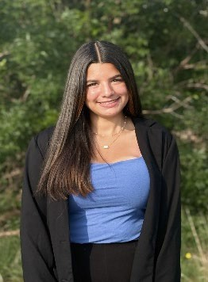

Kojo Akowauh
Vice President
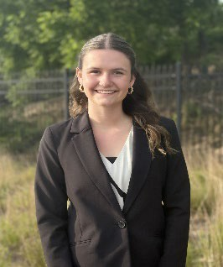

Piper Germain
Treasurer


Yousuf Saad Qadri
Youth Board Member
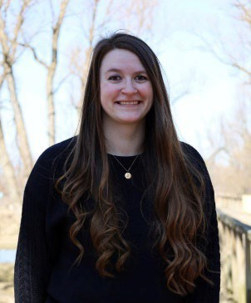

Sidney Sheehan
Adult Board Member

Adaline Bisciligia
Secretary


Ethan Mason
Youth Board Member
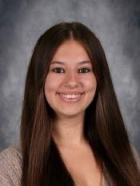

Madison Stangel
Youth Board Member
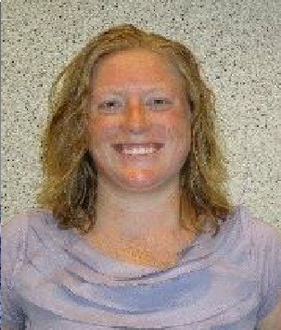

Alison Voss
Adult Board Member

Dania Decross
President
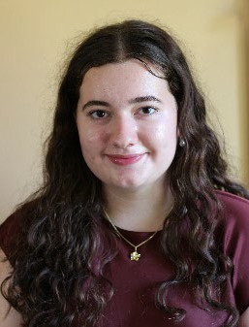

Elisabeth Palao Frideres
Youth Board Member
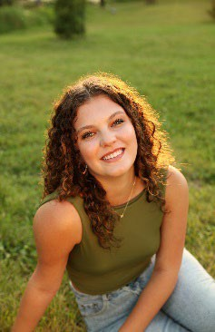

Kendall Youra
Youth Board Member
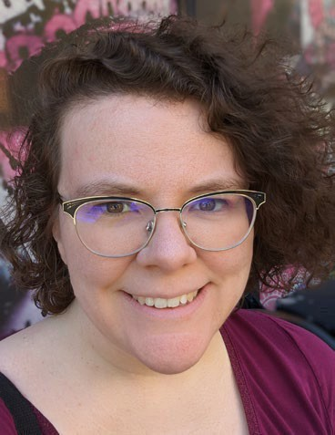

Amy Rae Weaver
Adult Board Member

Committees

Membership Committee
(Co-chaired by the Treasurer and an Adult Board Member)
The Membership Committee provides leadership for recruitment of board member applicants, interviews, and selection of new board members. New board members must be selected by the third Tuesday in April. Committee members include:

Treasurer: Piper Germain | Youth: Madison Stangel
Adult: Alison Voss | Youth: Dania Decross

Outreach Committee
(Co-chaired by the Vice President and an Adult Board Member)
The Outreach Committee is responsible for planning and coordinating special events in the community that involve the YAR Board. Examples include two community service projects, the end of the year celebration, fundraisers, and other community events. Committee members include:
Vice President: Kojo Akowauh | Youth: Kendall Youra
Adult: Sidney Sheehan | Youth: Ethan Mason

Media Committee
(Co-chaired by the Secretary and an Adult Board Member)
The Media Committee is responsible for promoting YAR and YAR granting opportunities digitally. They coordinate YAR social media by working with Extension and the United Way of Kenosha County. Committee members include:

Secretary: Adaline Bisciligia | Youth: Elisabeth Palao Frideres
Adult: Amy Rae Weaver | Youth: Yousuf Saad Qadri

Endowment Committee
Two youth YAR Board members will attend YAR Endowment Committee meetings and provide youth representation to the YAR Endowment Committee.

Youth Endowment Member: | Ethan Mason
Youth Endowment Member: | Yousuf Saad Qadri

Kenosha County Youth As Resources Board of Directors Meeting Schedule 2026-2027

Date & Time | Location | Agenda
Tuesday, September 15, 2026  4:30-5:00 (Officers)  5:00-7:00 (Board) | Kenosha Area Business Alliance/United Way 5500 6th Avenue, Suite 210  Kenosha, WI 53140 | Orientation and Training, Select Project Award
Tuesday, October 20, 2026  4:30-5:00 (Officers)  5:00-7:00 (Board) | Kenosha Area Business Alliance/United Way 5500 6th Avenue, Suite 210  Kenosha, WI 53140 | Grant Presentations
Tuesday, November 17, 2026  4:30-5:00 (Officers)  5:00-7:00 (Board) | Kenosha Area Business Alliance/United Way 5500 6th Avenue, Suite 210  Kenosha, WI 53140 | Committee Program Planning
Winter Service Project  Date/Time TBD | TBD | Service Project
Tuesday, December 15, 2026  4:30-5:00 (Officers)  5:00-7:00 (Board) | Kenosha Area Business Alliance/United Way 5500 6th Avenue, Suite 210  Kenosha, WI 53140 | Committee Program Planning
Tuesday, January 19, 2027  4:30-5:00 (Officers)  5:00-7:00 (Board) | Kenosha Area Business Alliance/United Way 5500 6th Avenue, Suite 210  Kenosha, WI 53140 | Interview Training, Program Planning, and Joint Board Meeting with YAR & Endowment Committee
Tuesday, February 16, 2027  4:30-5:00 (Officers)  5:00-7:00 (Board) | Kenosha Area Business Alliance/United Way 5500 6th Avenue, Suite 210  Kenosha, WI 53140 | Grant Presentations
Tuesday, March 16, 2027  4:30-5:00 (Officers)  5:00-7:00 (Board) | Kenosha Area Business Alliance/United Way 5500 6th Avenue, Suite 210  Kenosha, WI 53140 | Grant Presentations
Spring Service Project  Date/Time TBD | TBD | Service Project
Tuesday, April 20, 2027  4:30-5:00 (Officers)  5:00-8:00 (Board) | Kenosha Area Business Alliance/United Way 5500 6th Avenue, Suite 210  Kenosha, WI 53140 | Interview and Selection of New Board Members
Tuesday, May 18, 2027  4:30-5:00 (Officers)  5:00-7:00 (Board) | Kenosha Area Business Alliance/United Way 5500 6th Avenue, Suite 210  Kenosha, WI 53140 | Handbook Review,  Install New Board Members, Elect 2027-2028 Officers, and Celebration

Bylaws

NAME
  - This organization shall be known as Kenosha County Youth As Resources.

PARTNERS
  - Kenosha County Youth As Resources is a program of Extension Kenosha County.
  - The fiscal agent of Kenosha County Youth As Resources is the United Way of Kenosha County.
  - The Youth As Resources Endowment Committee provides oversight of the Youth As Resources Endowment Fund in collaboration with the Kenosha Community Foundation.

MISSION
  - Through grant-making, Kenosha County Youth As Resources empowers youth to design and implement projects that meet community needs.

BOARD MEMBERSHIP
  - Youth As Resources does not discriminate against anyone for reasons of race, color, gender/sex, gender identity, creed, disability, religion, national origin, ancestry, age, sexual orientation, pregnancy, marital or parental status, arrest or conviction record, or veteran status.
  - A background check is required of all adult members joining the YAR Board due to working alongside youth members.
  - Board members of Youth As Resources cannot simultaneously serve as Youth in Governance appointees (in accordance with Youth in Governance bylaws).
  - Board members of Youth As Resources:
    - Will be selected based on experience, interest, and commitment to the Youth As Resources philosophy and the Kenosha County community. Members will reflect the geographic, ethnic, professional, and economic diversity of the Kenosha County community.
    - The Board will consist of no more than 12 persons, 9 youth and 3 adults.
    - Youth members are defined as high school students. Adult members are classified as high school graduates who are 18 years of age and older.
    - All members must demonstrate a strong desire to participate, an overall good attitude, high levels of reliability, strong attendance, and show a willingness to work.
    - Board members are required to attend at least one YAR service project per year (one in fall and one in spring).
    - The YAR year will run from September through May.
    - Board members will sign the Youth As Resources/United Way Conflict of Interest Policy annually.

ELECTION AND REMOVAL OF OFFICERS
  - Board officers will be elected in May, unless extenuating circumstances occur. In the case of elections not taking place in May, elections will be rescheduled at the discretion of the YAR Board.
  - Board officers may be removed by a simple majority vote if the officer fails to fulfill the duties of their office.
  - Vacancies during the year will be filled by Presidential appointment and simple majority vote of the YAR Board.

MEETINGS AND ATTENDANCE
  - Official board meetings are held on the third Tuesday of the month from 5:00 pm – 7:00 pm at the United Way of Kenosha County/KABA Training Room (unless the meeting must be held virtually or an event prevents use of this room).
  - A quorum is required for motions, official business, and voting. A quorum is defined as at least 50% of the current YAR Board. A majority vote with a quorum is necessary to pass motions and fund allotments.
  - Members are expected to attend all board meetings. The Secretary will record attendance and unexcused absences. Members who have two absences will be removed at board discretion by board vote.
    - An excused absence is recorded at least two business days in advance.
    - An unexcused absence is when a board member does not attend a meeting without notifying the YAR President and/or YAR coordinator of absence prior.

GRANT GUIDELINES:
  - Projects must be youth-designed, youth-led, and presented by youth. Projects must be completed with a summary report and a project book.
  - Youth are defined as high school seniors or younger.
  - Failure to return summary report and/or project book may disqualify group from any future funding.
  - Usage of funds can be restricted by the YAR Board on a case-by-case basis.
  - Unused funds must be returned by the service group to the YAR Board upon completion of their service project.
  - Recipients of grants may not use grant money to discriminate on any basis.
G. Projects must serve the Kenosha County community.

- YAR board members are not permitted to submit a YAR grant proposal; however, they may be “associated” with a group who submits an application. The YAR Board member will recuse themselves from the discussion/voting on any proposal where they are a member of the group submitting the proposal.
- Projects are required to indicate that the project was funded by Youth As Resources.

LEONARD AND PATRICIA JOHNSON AWARD
  - Service groups that receive YAR grants and complete their service project during each YAR year are eligible for the Leonard and Patricia Johnson Award.
  - If a group completes their project in a year different from the year they received grant funds, they are eligible for the award during the year of project completion.
  - Criteria for the award include: Leadership, Citizenship, and Community Service.
  - Whenever possible, a member or members of the Leonard & Patricia Johnson Family will provide input into the selection of the award recipient.
  - Board members will vote on groups or individuals who meet the above criteria using a nominal group technique (voting with dots) and take into consideration the Johnson Family recommendations for the award recipient.

AMENDMENTS

  - Any amendments of the bylaws must be approved by a two-thirds vote of the YAR Board.
* * * *

Youth As Resources Pledge
As a member of Kenosha County Youth As Resources, I will support my community by giving back.
I will transform myself by building knowledge and skills. I will commit myself to the idea that youth can be leaders.
I am a resource.

The standard of behavior at United Way of Kenosha County is that all staff, volunteers, and board members scrupulously avoid conflicts of interest between the interests of the United Way of Kenosha County on one hand, and personal, professional, and business interests on the other. This includes avoiding potential and actual conflicts of interest, as well as perceptions of conflicts of interest.
I understand that the purposes of this policy are to protect the integrity of United Way of Kenosha County’s decision-making process, to enable our constituencies to have confidence in our integrity, and to protect the integrity and reputations of volunteers, staff and board members. Upon or before election, hiring or appointment, I will make a full, written disclosure of interests, relationships, and holdings that could potentially result in a conflict of interest. This written disclosure will be kept on file and I will update it as appropriate. In the course of meetings or activities, I will disclose any interests in a transaction or decision where I (including my business or other nonprofit affiliations), my family and/or my significant other, employer, or close associates will receive a benefit or gain. After disclosure, I understand that I will be asked to leave the room for the discussion and will not be permitted to vote on the question.


I understand that this policy is meant to supplement good judgment, and I will respect its spirit as well as its wording.

Signature Date

Kenosha County Youth As Resources is a program of Extension Kenosha County in partnership with the United Way of Kenosha County.

The cornerstone of the Youth As Resources program is the idea that youth can make meaningful, not just symbolic, contributions to their communities, and that these contributions provide important opportunities for youth to grow professionally and personally.

In memory of her husband Leonard Johnson, Patricia Johnson donated the initial funds to start the Endowment Fund in 2008 with the Kenosha Community Foundation. The fund is designed to ensure the long-range sustainability of the Kenosha County Youth As Resources program, as only the earnings of the fund will be used to support local youth-led service projects.

The Kenosha County Youth As Resources (YAR) Endowment Committee provides oversight of the Youth As Resources (YAR) Endowment Fund in collaboration with the Kenosha Community Foundation.
The Endowment Committee will assist the Kenosha County Youth As Resources (YAR) Board in creating an awareness of the Endowment Fund and the benefits it offers to the Kenosha County Youth As Resources (YAR) program. The Committee will direct the solicitation of funds through donations of cash or property from various sources including bequests and memorials.

Earnings from gifts and bequests to the Fund may be used for projects or programs recommended by the Endowment Committee, and then approved by the Director of Extension Kenosha County.

The Youth As Resources Endowment Committee consists of no fewer than 5 members and no more than 9 members.

The fiscal year of this Fund shall be January 1 – December 31.

Anyone can contribute, and any size gift is accepted. Cash gifts, memorials, bequests, and property, including stock are appreciated. All contributions and gifts are tax deductible as provided in Section 501(c)(3) of the Internal Revenue Service Code.
Donations can be sent to the Kenosha Community Foundation, 600 - 52nd Street, Suite #110, Kenosha, WI 53140.

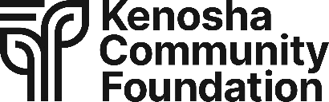

Leonard and Patricia Johnson Award Selection Criteria

Purpose:
The purpose of Leonard and Patricia Johnson Award is to recognize an outstanding Youth As Resources project annually.

Criteria:
- Leadership
- Citizenship
- Community Service

Groups and/or individuals who receive a Youth As Resources grant and complete their service project during each Youth As Resources year are eligible for the Leonard & Patricia Johnson Award.
If a group or individual completes their project in a year different from the year they received grant funds, they are eligible for the award during the year of the project completion.
Whenever possible, a member or members of the Leonard & Patricia Johnson Family will provide input into the selection of the award recipient.
Youth As Resources Board members will vote on groups and/or individuals who meet the above criteria using a nominal group technique (voting with dots) and take into consideration the Johnson Family recommendations for the award recipient.

Leonard and Patricia Johnson Award Plaque:
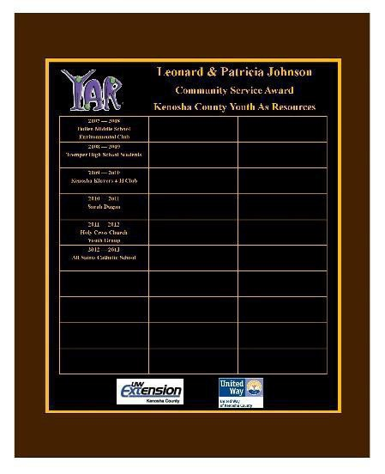
Award recipients will have their name engraved on the award plaque and will be presented a certificate at a Youth As Resources Board meeting.

